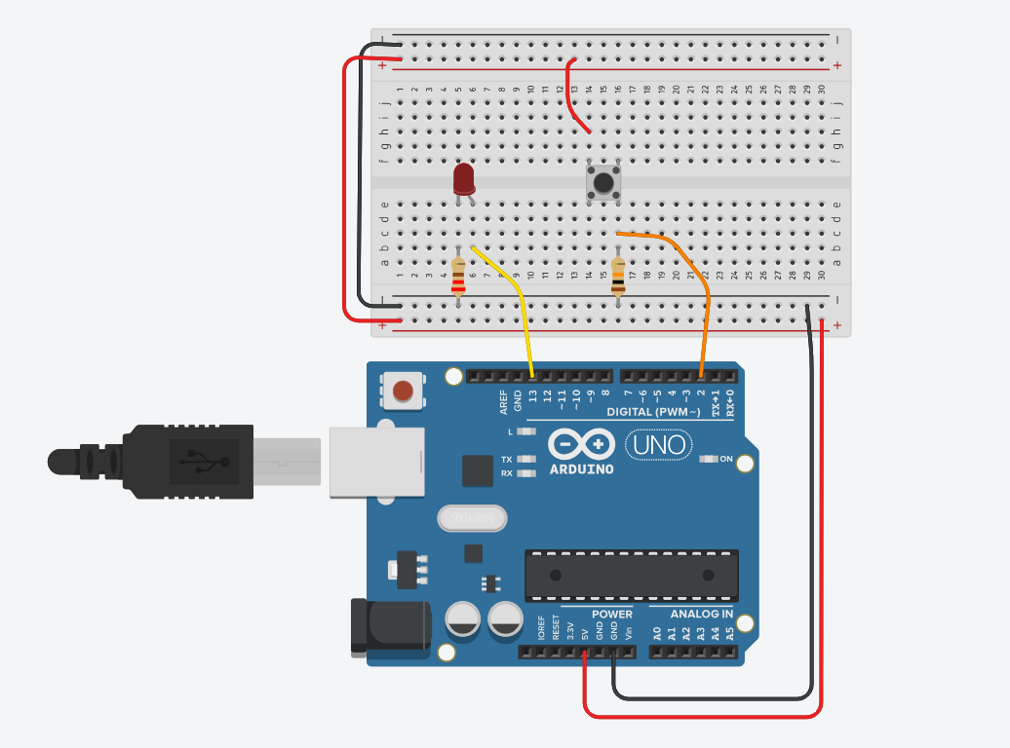
int buttonState = 0;

void setup()
{
pinMode(2, INPUT);
pinMode(LED_BUILTIN, OUTPUT);
}

void loop()
{
// read the state of the pushbutton
buttonState = digitalRead(2);
// check if pushbutton is pressed. if it is, the
// button state is HIGH
if (buttonState == HIGH) {
digitalWrite(LED_BUILTIN, HIGH);
} else {
digitalWrite(LED_BUILTIN, LOW);
}
delay(10); // Delay a little bit to improve simulation performance
}
CONCLUSION:- IN THIS PRACTICAL WE HAVE LEARN PUSH BUTTON WHEN WE PRESS BUTTON THE LIGHT WILL GLOW.

